DuPont Research Analysis Report and Project
Name
Professor
May 1, 2019

Abstract
DuPont analysis is a model that was made popular by the company behind the name – DuPont Corporation. It forms an important tool that is used to analyze company performance indicators. The DuPont identity is used to decompose the different factors that drive Return on Equity or ROE. The decomposition of ROE allows investors and other stakeholders to concentrate on the important indicators of financial performance to more closely identify the strengths and weaknesses faced at the company level. Of the dominant financial indicators that drive return on equity include operating efficiency, efficiency in the use of assets, and financial leverage. Breaking down these indicators, it is realized that operating efficiency is represented by profit margin (net) divided by revenue collected or total sales made. Asset use efficiency is represented by asset turnover ratio and financial leverage is represented by equity multiplier, which is the average of assets divided by average equity. In summary, the DuPont formula is represented as;
DuPont Analysis = Profit Margin (Net) x Asset Turnover x Equity Multiplier
This can as well be written as;
DuPont Analysis= (Net Income)/Revenue x Sales/ (Average Total Sales) x (Average Total Assets)/ (Average shareholders' equity)
This analysis will entail a company in the health care industry namely Stryker Corporation and its close competitor Cigna Corporation. Stryker Corp. is a publicly traded company listed under the New York Stock Exchange (NYSE) based in the United States. Cigna is also based in Suburban Bloomfield America but trades globally.
Introduction
Stryker Corp. has an interesting history that is innovation rooted. The initiator of this company, Dr. Homer Stryker of Michigan conducted a research and found out that some of the medical products that were being offered in the industry had less satisfaction giving the patient less utility for that matter. He came up with this company with the aim of inventing new products that would better the situation by then. With a prime aim of helping patients stay healthier and more active through the products and services he intended, the company grew and today it is a global leader in the medical technology industry.
Stryker Corp’s Ratio Analysis
Financial ratios are tools that are used to evaluate a given company. They are represented mathematically to compare financial statement accounts. Investors, creditors, management, and owners of the business need this kind of analysis to understand the value of a business as well as the areas that need to be improved on. Investors look at the same to decide whether to increase, decrease and/or maintain their levels of investments in the business. It is globally known that these tools are the most popular as far as business analysis and financial stand are concerned. It is very easy to understand and compute ratios. They are also used in the comparison of different companies in different or similar industries - the main reason behind this paper. They will allow for the comparison of Stryker and Cigna Corporations in terms of their strengths and weaknesses.
Current ratio
This is efficiency as well as a liquidity ratio measuring a company’s ability to settle its short-term liabilities or outside claims using its current assets. Logically, an investor would be interested in a company whose current ratio is high since it shows that the company will be able to make its current outstanding debt payments. The current ratio is calculated by dividing current assets with current liabilities. Stryker Corp. current ratio at the end of 2018 was 2.02. This ratio was lower than the industry mean of 2.71. In the last 5 years, the company’s highest current ratio reported was 4.76 and the lowest 1.61 with a median of 2.61. From the calculations provided in excel, it is evident that the company’s current ratio deteriorated from in 2017 and 2018. Cigna Corp had issues that have led to difficulties in meeting its current liabilities. Its current ratio has remained 0.00 since 2014. This is an indication the company is not performing we and its financial strength is dying. Investors will not be interested in investing in such a company.
Quick ratio
This ratio is also known as the acid test ratio. It is a liquidity ratio measuring a company’s ability to settle its current liabilities but this time using its quick assets only. Quick assets entail the ones that can be converted into cash within a period of 3 months or 90 days. Stryker Corporation’s quick assets include; cash and its equivalents, accounts receivables minus any allowances, and marketable securities. The company’s total quick assets fell from 6,572 USD million in 2014 all through up to date. This has had a direct impact on the company’s quick ratio as calculated in the excel attachment. Stryker’s quick financial ratio as at the end of 2018 was 1.25. This has been high compared to its Health Care industry ration which was 1.13. Sector-wise, the company can be gauged at a better place considering that its sector average was 0.84. Cigna Corporation is an insurance company whose quick ratio is never calculated. Apparently we assume zero values.
Cash Ratio
Also known as the cash coverage ratio; it’s a liquidity ration measuring the ability of a company to settle its liabilities using cash and cash equivalents solely. This ratio exempts all other assets from settling off current liabilities. It is important to note that current debt can only be settled by the use of cash only and this is that basic argument behind this ratio. Creditors will always examine a company’s cash ratio before any finances are procured. Companies that maintain enough cash balances are mostly preferred by investors as well as creditors. Cash ratio is calculated by adding cash and its equivalents and then dividing the solution by total current liabilities.
As at December 2018, Stryker Corporation had a cash ratio of 0.77 which had deteriorated from 1.16 in 2015. But compared to the Health Care Equipment & Services sector average of 0.43, the company was far much above this average. Similarly, it was slightly above the industry average of 0.73. Cigna Corporation had a cash ratio of 0.00 since it had issues with its financials. Comparing the two companies, Stryker could be the most preferred by investors.
Days sales outstanding
This is also known as the average collection period. It is used to identify the number of days a company takes to collect its cash from credit buyers. This ratio examines the efficiency of a company’s collection. The sooner cash is collected, the sooner it can be invested in capital activities. It is computed by multiplying period total credit sales by the number of days, mostly 365 days, and dividing it by net credit sales.
Stryker Corp days sales outstanding as at of December 2018 was 56.06. In the past 13 years, the highest value of this ratio was 64.47 and 59.31 was the lowest. The median of the same has been 62.27. Considering the industry days sales outstanding, Stryker’s value was not bad off. The industry had a median of 69.21 days. Yet still, Cigna Corp. had no days sales outstanding since the company sales had drastically fallen. Logically, there was nothing to collect.
Inventory turnover
This is an efficiency ratio that depicts that manner in which a company manages its inventory in a given period of time. Mostly, the ratio compares the cost of goods sold with the period’s average inventory. In other words, the ratio measures the efficiency in making income from the sale of inventory. Inventory turnover is calculated by dividing the cost of goods sold with the average inventory.
Stryker Corp is reported to have sold 1.65 times of its inventory in the year ended Dec 2018. However, the sector inventory turnover was 2.97 far above the company’s value. Industry inventory turnover was similarly very high at 3.67. Though industry wise the company’s inventory turnover falls too low, compared to the company under analysis Cigna Corp, the company’s ratio is far much better since Cigna has been reporting zero inventory turnover over the years.
Production cycle
The company sales have increased from 7.9 percent with an operating income of margin of 18.7 percent. The EPS is reported to have increased to $9.34, a margin of 248.5 percent. The adjusted EPS, however, has increased to $7.31, which represents a margin of 12.6 percent. This is an analysis of 2018. This year sales are expected to grow at a range of 6.5 percent to 7.5 percent. The past 5 years have been an indication of growth.
Accounts receivables turnover
The company accounts receivables are created from the delivery of a product or a service without immediate payment. Stryker Corp’s accounts receivable for this year’s first quarter that ended March was 2284 million USD. The days’ sales outstanding is what measures the accounts receivable of a company and Stryker Corp’s for the same period was 59.28 days. According to Ben Graham’s calculations, the accounts receivable are 75 percent of any company’s book value, Stryker Corp’s is reasonable. The last 5 year accounts receivable values for the company are represented in a respective manner since 2014 as 1572, 1662, 1967, 2198, and 2332 all in million USD. The other company Cigna Corp, has been pretty much higher compared to Stryker Corp. The values of the same for the periods are 9837, 10507, 9555, 8667, and 15704 million USD.
Average collection cycle
This is an activity ratio that equates the number of days in the period collections is made divided by the receivables turnover. Stryker Corp’s average collection cycle for the last 5 years include; 63 days in 2018, 64 in 2017, 63 in 2016, 61 in 2015, and 59 in 2014. The period has slightly increased but this can be attributed to the growth of creditors and sales for that matter.
Accounts payable turnover
A liquidity ratio used to exhibit the company’s ability to settle its accounts payable by the comparison of credit purchases (net) and average accounts payable in a given period. This is a common ratio that investors consider so closely before making an investment in a given company. Dividing total purchases with average accounts payable gives the accounts payable turnover ratio. Stryker Corp had a payable turnover of 7.22 at the end of 2018. In 2017, it was a bit high at 8.77. This means that the ratio has continued to deteriorate over the years. It is indicated by the further past values of 2016, 2015, and 2014 which are 8.76, 8.16, and 10.00 respectively. This reduction implies that suppliers and credit buyers have either increased or rather the level of repayment has declined significantly. But a reasonable conclusion is still not due until all necessary computations are factored.
Average payment cycle
The company’s average payables payment period for the past 5 years include 52 days in 2018, 42 in 2017, 42 in 2016, 45 in 2015, and 36 in 2014. This implies that the company’s liabilities are increasing as the company grows. It shows that the company has invested over the years to fit the market growth. Compared to its industry, Stryker Corp lags a bit behind which may implicate a prospective future. Cigna Corp’s average payment period is undetermined bearing in mind that it is an insurance company.
Cash conversion cycle
The cash conversion cycle ratio is a gauge that converts a company’s investment in inventory as well as other investment factors into cash. In other words, it is a cash flow calculation that measures a company’s efficiency. A company that is able to sell its inventory and collect cash from customers the shortest period is desirable as opposed to one which takes the longest periods. Calculation of this ratio is made by adding days’ inventory outstanding to days sales outstanding and then subtracting days payables outstanding form the result. Stryker corporation’s cash conversion cycles for the last 5 years is 199 in 2014, 195 in 2015, 214 in 2016, 233 in 2017 and 243 in 2018. This number is not used to judge the company alone; ROE and ROA are factored to reach a constructive conclusion. This company’s cash conversion cycle is better off considering a much higher number of its industry. Cigna International is more of a health insurance company and therefore the cash conversion cycle does not exist for its case.
Cash coverage
The cash coverage ratio is used to measure the ability of a company to settle off its liabilities with the operating cash flow. Can the firm’s cash flow from operations pay off its obligations when they are due? This is the basic argument brought around by this ratio. Stryker’s cash conversion ratio for the year ended December 2018 was 0.38. The industry median in the same year was 2.32 leaving the far behind. From 2014 the company’s cash conversion ratio was a bit high at 1.26 but decreased from 2015 to date. Cigna Corp’s cash conversion ratio over the same years has been below average. The ratios since 2014 were 0.28, 0.38, 0.63, 0.55, and 0.09 in the year ended December 2018.

Cash to Debt Ratio | = | Cash, Cash Equivalents, Marketable Securities | / | Total Debt
 | = | Cash, Cash Equivalents, Marketable Securities | / | (Current Portion of Long-Term Debt | + | Long-Term Debt & Capital Lease Obligation)
 | = | 3699 | / | (1373 | + | 8486)
 | = | 0.38

Equity ratio
Equity ratio helps stakeholders determine the number of assets that have been financed by the owner’s investments. This ratio total equity to total assets. It is, hence, a solvency ratio or an investment leverage ratio. To determine the sustainability of a business, this ratio is of importance. Its calculation is simple; diving the amount of shareholder’s tangible total equity by that of total assets. Stryker’s current equity ratio is 0.45. Compared to the industry mean of 0.63, the company’s equity to asset ratio is ranked to lag behind 76 percent of the 309 companies in the international industry. Cigna Corp has an equity ratio of 0.27 compared to a 0.38 margin in its industry with only 27 companies globally. Its historical data of the same is shown as; 2014-2018, 0.19, 0.21, 0.23, 0.22, and 0.27. Cigna could not be desirable in regard to this ratio but yet still, a single computation cannot make an effective concussion.
Equity to Asset (A: Dec. 2018 ) | = | Total Stockholders’ Equity | / | Total Assets
 | = | 11730 | / | 27229
 | = | 0.43

Debt-to-equity ratio
The debt to equity ratio is a financial liquidity measure that compares the total debt of a company to its total equity. It is represented as a percentage. It tells stakeholders the amount of financing that is derived from creditors and investors. A higher debt to equity ratio indicates that the company is financed mostly by loans and shareholders. Different industries have different equity ratio benchmarks something which is factored when an analysis is being done. Stryker’s debt to equity ratio has increased in the past 5 years since the company has increased shareholders and loaned items. The industry has similarly reported similar increments over the past 5 years. Compared to Cigna Corp. the company is much better given the fact that Cigna has acquired loaned items to run and maintain the business. Cigna’s debt to equity ratios for the past 5 years from 2018 are 1.04, 0.40, 0.37, 0.43, and 0.48 respectively.
Leverage ratio
The company’s debt to equity has greatly decreased from 1.01 in 2014 to 0.91 in 2015. This resulted from a decrease in debt of approximately 1 billion USD when compared to the company’s equity. The debt ratio indicates that the company’s debt decreased at a huge rate compared to total assets which decreased slightly in the same period. From the values of the long term debt ratio to capitalization, it validates that the company needs to finance their business activities using long term debt especially in periods of low-interest rates.
Operating profit margin
This is a profitability ratio that is used to measures the percentage of operating income that makes up total revenues. It exhibits the number of revenues that are left after operating or variable costs have been settled. It helps investors and creditors determine the profitability of a company’s operations. It is calculated by dividing operating income with net sales. This company under analysis has maintained an operating profit margin over the past 4 years as shown in the excel file at above 18.40 percent. In 2014, however, the ration was far way too low (12.88 percent). Compared to Cigna Corp, Stryker’s operating margin is nearly a double. The Cigna’s operating margin ratios for the last 5 years are as follows; 2014 – 9.46, 2015 – 8.78, 2016 – 7.75, 2017 – 9.43, and 2018 – 8.55. Stryker Company is far much better than Cigna would be. Industry-wise, Stryker is reported to have been doing pretty well since the interested average of operating margin was 18. 84 percent.
Net profit margin
Net profit margin is a profitability gauge that exhibits the percentage of each dollar that a company earns and ends up as a profit during a given period in time. It is a clear indication of the profit that a business makes from dollar sales. It is calculated by taking a company’s net profit by the total revenue in a given period. The net profit margin for the past five years for Stryker company is; 26.12 percent in 2018, 8.20 percent in 2017, 14.54 percent in 2016, 14.47 percent in 2015, and 5.32 percent in 2014. This was high above its healthcare sector margins. Compared to the industry, however, 2018 was a good year for Stryker Corp. The rest of the years, however, the company lagged far much behind.
Return on total asset
The return on total assets is an efficiency ratio that shows how a company manages its assets to make profits in a given period. Stryker Corp’s return on total assets for the period under study is 13.05%, 4.60%, 8.06%, 8.86%, and 2.91% from 2018 to 2014 respectively. Return on total assets for this company is above the sector and industry mean. Cigna Corp. has implicated much lower return on asset ratios over the years.
Return on common equity
Return on equity is a measure of profitability in a company. The ability of a firm to generate profits from its investor investments is known as return on common equity. Stryker Corp corresponding values of this ratio are; from 2018 to 2014 30.29%, 10.23%, 17.25%, 16.91%, and 5.99% respectively. This has been below the sector’s mean ROE as well as the Health Care industry. 2018, however, was an enticing year for the company since ROE was very high as compared to both the Health Care industry and the Health Care Equipment & Services sector.
Equity multiplier
This is a ratio that analyses the debt of a company and its equity financing strategy. The higher ratio is an implication of a high percentage of assets funded by debt other than equity. This implicates that investors have funded a smaller percentage of assets as compared to investors. The company’s equity multiplier is derived from the company’s total assets and stakeholders’ equity. As shown:
27,229 | 22,197 | 20,435 | 16,247 | 17,713
11,730 | 9,966 | 9,550 | 8,511 | 8,595
2.32 | 2.23 | 2.14 | 1.91 | 2.06

Dividend payout
As of today, the Stryker Corporation has a dividend payout ratio of 0.21. The year that ended in March 2018, the company had a dividend payout ratio of 0.48. This ratio is ranked lower than 100 companies in the global industry. However, the company dividend per share grew by 10.60 percent per annum in the last 4 financial quarters.
Cigna Corporation has a dividend yield of 0.02 percent. However, its payout ratio for the last financial year is reported as 0.00. Over the last like 13 years, the company has had an annual dividend growth of 0.57 percent as the highest, the lowest as 0.02 percent and a median of 0.05 percent. Cigna, however, has maintained a reputable market cap of 61,002 USD compared to other firms in the industry. Cigna and Stryker are incomparable based on this ratio since they operate at different markets.
Dividend Payout Ratio | = | Dividends per Share (A: Dec. 2018 ) | / | EPS without NRI (A: Dec. 2018 )
 | = | 1.93 | / | 9.34
 | = | 0.21

Dividend Yield Ratio
Stryker’s dividend yield ratio as of today is 1.06 percent. This ratio falls lower than 112 companies in the same industry, globally. For a decade or so, the company has had the highest dividend payout ratio of 0.94, a lowest of 0.05, and a median of 0.31. As of today, Cigna Corp. has a dividend payout ratio of 0.02 percent. This company’s stock dividend yield is close to a 10-year low. It has been lower than the other 31 companies in the global industry.
Cigna Corp: 2014 2015 2016 2017 2018
0.04 0.03 0.03 0.02 0.00
Stryker Corp: 1.34 1.52 1.31 1.13 1.23

Conclusion
From the analysis done, I have found that Stryker Corp. is a relative company that is not so inviting to invest on. However, compared to Cigna Corporation, it is a good choice of investment. Most importantly, the company has outperformed its industry thus showing its ability to grow sales volume via acquisitions and internal growth. The company has a long term debt that is increasing, and gradually loses its ability to offset its external claims using its operating income and competition in the market.

References
Gepp, A., & Kumar, K. (2015). Predicting financial distress: A comparison of survival analysis and decision tree techniques. Procedia Computer Science, 54, 396-404.
Wang, L., Gopal, R., Shankar, R., & Pancras, J. (2015). On the brink: Predicting business failure with mobile location-based checkins. Decision Support Systems, 76, 3-13.
Zhang, X. J. (2016). On Modified DuPont Method: Analysis of Firms with Negative Net-Financial-Obligations.
https://www.stock-analysis-on.net/NYSE/Company/Stryker-Corp/Ratios/Profitability#ROA
https://www.myaccountingcourse.com/financial-ratios/equity-multiplier
https://www.gurufocus.com/term/Accts+Rec./SYK/Accounts-Receivable/Stryker%20Corp

Appendices - Balance Sheet 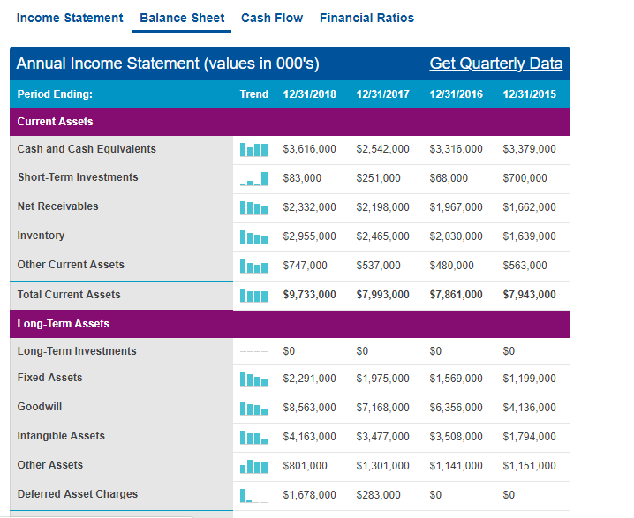 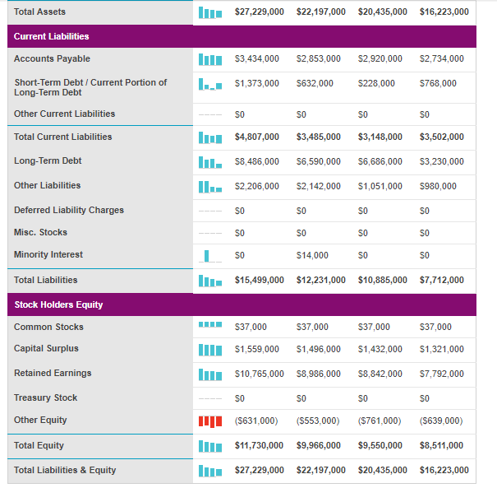

Income Statement
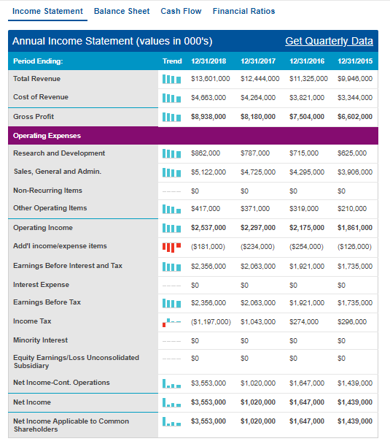
Cash flow
